Funding for Local Transport:
Safer Roads Fund

Application Form

The level of information provided should be proportionate to the size and complexity of the scheme proposed. As a guide, we would suggest around 10 to 15 pages including annexes would be appropriate.

A separate application form should be completed for each scheme

Application Information
Local Authority Name(s)* | Suffolk County Council
*If the bid is a joint proposal, please enter the names of all participating authorities specifying which will act as lead
Project Manager Name: | Luke Barber
Name of the officer with day-to-day responsibility for delivering the proposed scheme
Position: | Strategic Transport and Policy Manager
E-mail Address: | Luke.Barber@Suffolk.gov.uk
Telephone number: | 01473 264412
Postal Address: | Suffolk County Council,  Endeavour House,  8 Russell Road,  Ipswich,  Suffolk,  IP1 2BX
Deputy officer details: | Andrew Bramwell  Andrew.Bramwell@Suffolk.gov.uk
Supply details for an officer to contact if Project Manager not available- name and e-mail is sufficient

When authorities submit a bid for funding to the Department for Transport (DfT), as part of the Government’s commitment to greater openness in the public sector under the Freedom of Information Act 2000 and the Environmental Information Regulations 2004, they must also publish a version (excluding any commercially sensitive information) on their own website within two working days of submitting their final bid to the Department for Transport. The Department for Transport reserves the right to deem the business case as non-compliant if this is not adhered to.
Please provide the web link to where this bid will be published: | https://www.suffolk.gov.uk/roads-and-transport/transport-planning/grant-and-funding-applications-for-transport-improvements

SECTION A – Scheme Description and Funding Profile

A0. AU Scheme Designator | 31 | A1156 Ipswich
This is a DfT reference for internal reporting purposes

A1. Scheme Name | A1156 Ipswich – Norwich Road
Please provide a scheme name, starting with the road number, that you will use as your reference for the project. This can match the ‘Scheme Designator’ above.

A2. Headline Description
Please provide a brief description of the proposed scheme (maximum 250 words)
Based on previous collision data along the A1156 and baseline FSI estimation profiles, the scheme is predominantly aimed at improving the interaction of travel modes at junctions and reducing speed at higher risk sections along the route. In addition, less intrusive measures where we have geographical limitations, would be implemented to reduce roadside hazards and possible head on collisions between vehicles.

Below is the current star rating on the A1156, within the scheme area, based on current baseline data -

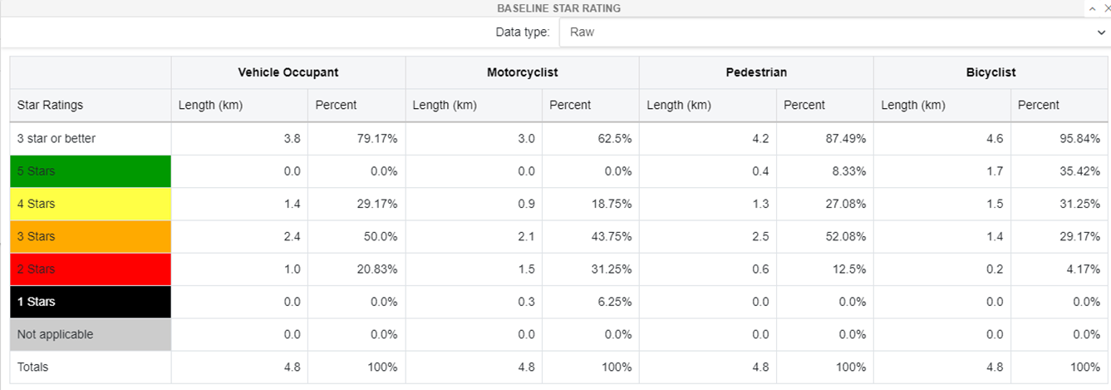

The proposed scheme is expected to prevent 6.09 fatal and serious injuries over the next 20-year appraisal period, with a reduction of 11.9% compared to baseline data and an overall BCR of 5.12.

With the introduction of the proposed scheme, the below table shows the expected star rating along the A1156 within the scheme area -

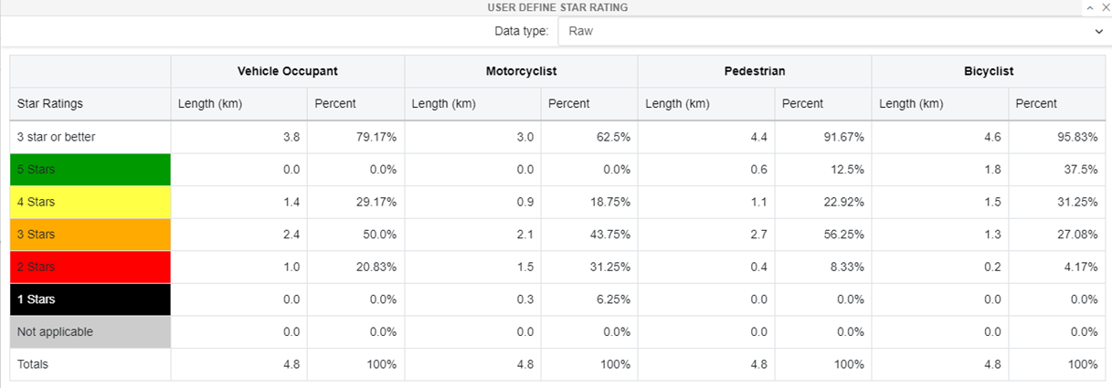

Pedestrians are to benefit the most from the scheme with a new percentage of 91.67% of the route becoming 3 star or above along much of the route, a 4% increase from the baseline star rating.

A3. Geographical Area
Please provide a short description of the area covered by the bid (maximum 100 words)

Please attach, as an annex, a map/maps showing the route and location of the scheme including existing transport infrastructure and other points of particular interest e.g., development sites, areas of existing employment, geographical constraints etc
From the Northwest outskirts of Ipswich where the A14 meets the A1156 at the Anglia Retail Park and Whitehouse Industrial estate, the scheme continues in a South-easterly direction towards Ipswich Town centre under Bramford Lane Railway Bridge, crosses the intersection with the A1214, north of the town centre adjacent with Sailmakers shopping centre and Tower Ramparts Bus Station finishing to the East of Ipswich where St. Margarets Road meets Woodbridge Road.

Grid References  Please provide Easting/Northings for the start and end of your scheme | Start  613507/247609 | End  616660/244706

A4. Equality Analysis
Please provide us, in a separate annex, your plans for undertaking your equality analysis in line with the Public Service Equality Duty

SECTION B – The Business Case

B1. The Scheme- Summary/History
Please outline what the scheme is trying to achieve (maximum 300 words)
The aim of the scheme is to improve the interaction of travel modes at junctions and reduce vehicle speed at high-risk sections along the route. Previous collision data trends have shown a worrying trend of vehicle collisions with cyclists and pedestrians around junctions which flow into the A1156 from areas of densely populated residential and retail areas.

The engineering improvements around junctions would reinforce the highway code and give priority to pedestrians and cyclists at junctions along numerous locations along the route. This would hopefully encourage more people to walk and cycle along this route to gain access to local educational settings, places of worship, the town centre and local retail outlets.

Encouraging and promoting more active travel modes for residential areas along the A1156 and the surrounding area would fundamentally improve people’s health, reduce congestion and improve air quality. Currently, the A1156 does interact with three out four of Ipswich Borough Councils currently recognised AQMAs (Air Quality Management Areas). In time, the improved air quality along the route resulting from the implementations of the scheme would help support the aims to remove the AQMAs in this area.

B2. The Strategic Case
This section should set out the rationale for making the investment and show evidence of the existing safety problems (maximum 750 words)

Supporting evidence can be provided in annexes if it is clearly referenced in the strategic case. This may be used to assist in judging the strategic case arguments but is unlikely to be reviewed in detail or assessed in its own right- do not rely solely on any annex provided material being assessed.

- What and where are the current problems to be addressed by your scheme?
- What options have been considered and why do those proposed provide the best solution?
- What barriers to delivery are currently identified and any mitigation known?
- What other funding streams have been considered or, if already in place, how might they influence or impact this project e.g., Active Travel funding?
- Do you anticipate the route will be impacted by external issues i.e., archaeological or environmental?
- What is the anticipated impact and the expected benefits/outcomes of this scheme?
It has been identified within the iRAP tool FSI estimation profile that there is a continuous risk of head of collisions between vehicles and interactions with travel modes, especially at intersections, throughout the route. Below is the FSI estimation profile for the selected section of the A1156 for all travel modes -

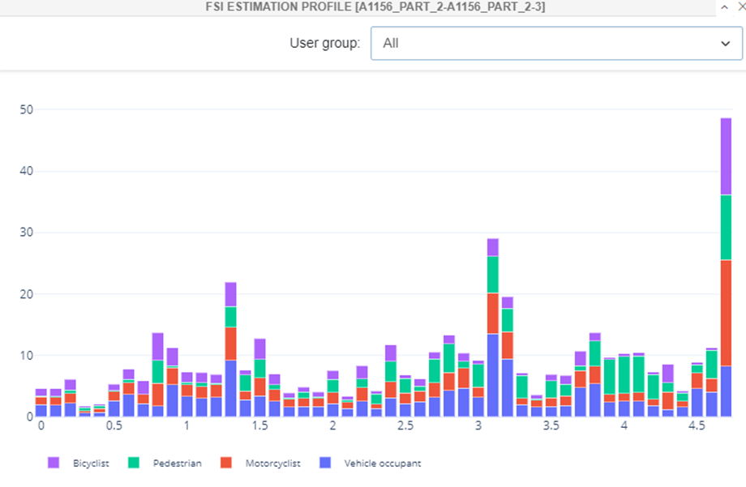

In order to treat the risk of head on collisions between vehicles, we have identified the need to introduce a wide centreline along most of the route within the scheme area. Whilst central hatching would have been a preferred option, limitations in highway widths and improvements to cycle lanes throughout the route within future schemes has taken precedence over this option.

Improvements to safety at intersections along the route have been identified as a priority given previous collision data trends at junctions throughout the route. To promote and reinforce the highway code given its priority to pedestrians and cyclists, the introduction of nineteen flush crossings at intersections along the route would help improve the interaction of active travel modes with vehicles and reduce vehicle speed at these locations.

Three other locations within the FSI estimation profile from the iRAP tool have been identified as areas of significant risk.

Cumberland Street to Anglesea Road

It has been identified that this section of the A1156 is vulnerable to head on collisions, due to its lack of definition of vehicle pathways, and its roadside hazards due to their proximity to the highway. We have identified that a wide centreline treatment would improve vehicle pathway and a reduction in vehicle interaction. By relocating roadside hazards, like telegraph poles, to the back of the pedestrian walkway, this would further assist in active travel provisions being introduced to this route.

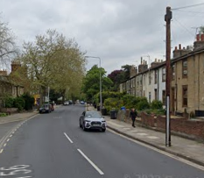

Castle Road to Meredith Road Junction

Whilst this section of the A1156 promotes an inbound Bus Lane and provision for bicyclists on either side of the carriageway, there is significant risk of vehicle run off and head on collisions.
In order to treat some of the risk along this section of the A1156 whilst continuing to encourage and promote sustainable travel, a wide centreline and removal of roadside hazards deemed the most feasible options.

A14 / A1156, Bury Road roundabout

The predominant risk associated with this section of the A1156, is the intersection (roundabout) which links the A14 to both the Anglia Retail Park and White House Industrial Estate. Whilst there is a low bicyclist and pedestrian flow in this location, it would benefit from pedestrian fencing around locations where crossing is an option. Furthermore, the introduction of a pedestrian crossing linking the small residential and business area to the far north of the section with the retail park would reduce risk for pedestrians and bicyclists from this isolated area.

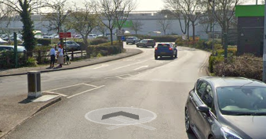

Barriers to delivery

Given the importance of the A1156 as one of the main arterial routes linking the A14 to Ipswich Town Centre, additional consideration would have to be given to residents, businesses, schools, and places of worship when the route (in places) would have to be closed to implement such highway improvements. Whilst every effort would be made to mitigate these restrictions, particular levels of disruption would take place.

Impacts and benefits

We don’t anticipate any external issues with the implementation of this scheme but, we do expect that some of the scheme measures could have some negative feedback and some political resistance to them. We would make it clear that these measures are in the interest of safety in the first instance whilst also promoting active travel, reducing congestion on the route and improving air quality.

B3. Finance - Project Costs
Before preparing a scheme proposal for submission, bid promoters should ensure they understand the financial implications of developing the scheme, including any implications for future resource spend and ongoing costs relating to maintaining and operating the asset, and the need to secure and underwrite any necessary funding outside the Department for Transport’s maximum SRF contribution.

Please complete the following table. Figures should be entered in £000s (i.e., £10,000 = 10)

Funding to be provided 2022/23 & 2024/25 | £000s
DfT SRF funding requested | £1,275,000
LA Contribution | 0
Other third-party funding | 0
Other Government funding | 0

B4. Finance – Local Contribution/Third-Party Funding
The non-DFT SRF contribution may include funding from other government funding streams or from organisations other than the scheme promoter. Please provide details of all non-DfT SRF funding contributions to the scheme costs.

This should include evidence to show how any third-party contributions are being secured, the level of commitment and when the funds will become available and if this will impact on delivery.

Please confirm if the funding has already been secured and provide supporting evidence (complete if applicable)
Not applicable

B5. Finance – Affordability and Financial Risk
Please provide a narrative setting out how you will mitigate any financial risks associated with the scheme and provide evidence on the following points, where applicable. Supporting evidence can be provided as an annex (maximum 500 words)

- What risk allowance has been applied to the project cost?
- How will cost overruns be dealt with?
- What are the main risks to project delivery timescales and what impact will this have on costs?
- What are your plans to understand and mitigate inflationary and/or supply chain pressures?
- What measures will you take to mitigate the risk of Fraud. Spotlight, an automated tool designed to perform due diligence checks, is available to all Local Authorities in England and Wales for Financial Year 22/23
Costs estimates have included a 20% risk allowance to ensure that moderate risks that materialise throughout the delivery of the project can be mitigated within the funding allocation.
Cost overruns will be addressed through funding from local sources. Private funding through developer contributions has been identified to mitigate risk of overspends and funding through the council’s Local Transport Plan allocation can be used to cover any further overspends.

Elements of the project, such as Traffic Regulation Orders, will be subject to separate statutory processes which represents and risk to the programme. Programme risks may incur more project costs as a result of inflationary pressures, material uplifts and sequencing of works. The risk has been recognised and contingency has been included in both the programme and the budget as mitigation.

The project will be delivered through one of the council’s established highway contracts, such as the new Suffolk Highways contract or the Eastern Highways Alliance. Contractors involved in both frameworks have been assessed based on costs to ensure value for money is delivered through the works and both frameworks contain provisions for the contractor to provide early warnings in relation to project budgets.

All works included within the project will be undertaken through established contract frameworks or from approved suppliers. Suppliers need to demonstrate a range of criteria to gain entry to these frameworks or to become an approved supplier and due diligence is undertaken throughout these processes to guard against fraud.

B6. Economics – Value for Money
Original BCR value (from RSF Report) | 5.4
Revised BCR (post final plans- to be completed later) | 5.12

B7. Commercial
Please describe the procurement strategy that will be used to select a contractor and set out the timescales involved in the procurement process that will show that delivery can proceed timeously (maximum 500 words).

Is there a preferred procurement process for the scheme? i.e., if it is proposed to use existing framework agreements or contracts, these must be appropriate in scale and scope

It is the promoting authority’s responsibility to decide whether or not their scheme proposal is lawful and the extent of any new legal powers that need to be sought. Scheme promoters should ensure that any project complies with the Public Contracts Regulations and should be prepared to provide confirmation of this to the Department for Transport, if required.

The Grant Recipient acknowledges and accepts that the Grant is awarded on the basis that the Funded Activities being undertaken using the Grant are, and will remain, -non-economic activities. The Grant Recipient shall ensure that measures are taken (where necessary), and maintained, to ensure that the Grant is not used to cross-subsidise any economic activity.

An assurance that a strategy is in place that is legally compliant and likely to achieve the best value for money outcomes is required from your Section 51 Officer (see Section D2 below)
The preferred procurement strategy for the scheme is to undertake the work through the council’s new highways contract operational from October 2023. It is recognised that the transition to a new contract may cause disruption to the delivery of new schemes, particularly improvement schemes, and the Eastern Highways Alliance, of which Suffolk County Council is a member, provides an alternative option to mitigate any delivery risks.

The council has extensive experience delivering works of this scale and nature, including a range of road safety, active travel and road capacity packages in recent years. The council also has extensive experience delivering a range of Traffic Regulation Orders on the highway network under its control, including those necessary for the nature of the scheme namely restricted movements. The legal powers provided to the council, as the highway authority covering all elements contained within the bid, are the only powers required to deliver the package of measures in its entirety.

The legal process will be undertaken through an instruction to Suffolk Legal and all relevant statutory processes will be undertaken to ensure the delivery of the package complies with all relevant legislation.

B8. Management - Delivery
Deliverability is one of the essential criteria for a bid and, as such, should set out if any statutory procedures are need before it can be delivered.

An outline project plan with milestones, typically in Gantt chart form, should be included as an annex, covering the period from submission of the bid to scheme completion. The definition of the key milestones should be clear and explained. The critical path should be identifiable and any contingency periods, key dependencies (internal or external) should be explained. Successful schemes will be subject to quarterly monitoring to assess progress against milestones and to track spend (narrative part of annex maximum of 300 words). -

A statement of intent to deliver the scheme within this programme, from a senior political representative and/or senior local official, should be attached as a further annex. –

B9. Management - Governance
Please name those responsible for delivering the scheme, their roles (e.g., Project Manager, SRO etc) and their responsibilities and how key decision are/will be made. Please also identify a contact to be used if escalation is required.

It may be useful to attach an organogram as an annex. -
Graeme Mateer, Head of Transport Strategy – Senior Responsible Owner

Responsible for key decisions in respect of the development and delivery of the package in consultation with Cllr Richard Smith MVO, Cabinet Member for Economic Development, Transport Strategy & Waste. Key decisions will be raised and resolved at regular briefings between the SRO, Cabinet Member and the project manager.

Luke Barber, Strategic Transport & Policy Manager – Project Manager

Responsible for the overall management of the package of measures including programme and budget management as well as fulfilling the council’s reporting requirements throughout the course of the project.

Julia Procter, Project Manager – Delivery Lead

Responsible for managing the day-to-day project activities and tasks including raising and approving works orders, fulfilling the council’s client responsibilities and co-ordinating works with the appointed contractor.

Andrew Bramwell, Senior Strategic Transport Planner – Policy Lead

Responsible for ensuring that the package fulfils the requirements of the fund including scoping works and other activities and reporting any departures from the agreed investment plan to the project manager.

Joseph Hough, Principal Transport Analyst – Monitoring & Evaluation Lead

Responsible for fulfilling the monitoring and evaluation requirements of the project across a range of metrics.

B10. Management – Risk Management
Risk management is an important control for all projects, but this should be commensurate with cost. For projects where costs exceed £100,000, a risk register covering the top 5 (maximum) specific risks to the scheme, and their likelihood of occurrence, should be completed.

Please ensure that, in the risk register costings, you have not included any risks associated with ongoing operational costs.

This should be attached as a separate annex. –

B11. Management – Barriers to progress
Please list any external barriers that you think may affect the delivery of your scheme (these can include, but is not limited to, procedural, constructural or environmental issues and/or delays)
Some elements of the package will be subject to separate statutory processes. For example, Traffic Regulation Orders will require a separate consultation and approval by the relevant Cabinet Member through delegated authority. In the event of objections raised to Traffic Regulation Orders required to deliver the scheme, the Cabinet Member may refer the decision to the Development & Regulation Committee.

The nature of the measures included within the package means that it is unlikely that any environmental constraints will be experienced during the delivery of the project and construction constraints have been highlighted in the risk register.

The scheme can be approved by delegated authority to the relevant Cabinet Member which will be arranged through the council’s well-established governance procedures. The relevant decision-makers will be briefed during periodic sessions throughout the project and at key decision points.

The scheme is entirely within public highway controlled by the council and there is no requirement for 3rd party land. The diversion of utility apparatus, however, will need to be undertaken by 3rd parties.

Section C – Monitoring, Evaluation and Benefits Realisation

C1. Benefits Realisation
Please provide details on the profile of benefits, including baseline benefits and benefit ownership, and explain how these will lead to outputs/outcomes. These should be proportionate to the cost of the proposed scheme. (Maximum 300 words)

This can be explained with logic maps, text descriptions or similar.
The council is committed to supporting the DfT’s requirements with regards to monitoring and evaluation. The council routinely collects and analyses road safety data, including through the STATS19 database, and develop a bespoke process for the purposes of monitoring and evaluating the effectiveness of the project. This will include the reduction in KSIs from a baseline established prior to the delivery of the scheme. The speed reduction measures and improvements to the safety of vulnerable road users aims to reduce the risk of KSIs by over 6 in the 20-year appraisal period. Consideration will be given to the development of a logic model to support the monitoring and evaluation of the scheme and the council will be open to sharing relevant information with other authorities to support best-practice and wider beneficial road safety outcomes. Monitoring and evaluation activities will be undertaken using existing data sources and as part of ‘business as usual’ processes to ensure that the activities provide the necessary outcomes and are proportionate to the scale and nature of the package.

The anticipated benefits of the scheme include:
- A reduction in the number of KSIs in the project area
- A reduction in road speeds in line with the traffic calming measures delivered as part of the package
- A reduction in KSIs for vulnerable road users such as pedestrians, cyclists and motorcyclists
- Provision of safe crossing points at key sites throughout the project area
- A reduction in the number of the collisions highlighted as being thematic to the route

C2. Monitoring and Evaluation
Evaluation is an essential part of scheme development and should be considered and built into the planning of a scheme from the earliest stages. Periodic monitoring to evaluate the outcomes and impacts of scheme interventions, as well as an evaluation of findings towards the end of a scheme, is important to show if the project has been successful.

Please set out how, and when, you plan to measure and report on the benefits identified in section C1, alongside any other outcomes and impacts of the scheme. Where possible, bidders should outline the baseline information they will use for their evaluation (maximum 500 words).

Scheme promoters are expected to complete reporting forms which will be sent from the Safer Roads Fund Team at DfT and to engage with the department’s external contractor’s requests for evaluation as well as contributing to platforms for the sharing and dissemination of lessons learned.
The baseline information to be used for the evaluation of the project includes:
- Walking and cycling flows
- Motor traffic flows
- Motorcycle flows
- Road speeds – mean speed and 85th percentile
- KSIs
- Hazards and risk identified through the iRap methodology

Gathering baseline data has been undertaken through the council’s routing data analysis processes and will be continually monitored throughout the delivery of the project and the subsequent monitoring period.

The council confirms it will comply with all requests to participate in additional research activities such as interviews and qualitative evaluation and complete forms and other requests from the DfT and its contractors.

SECTION D – Declarations

D1. Senior Responsible Owner Declaration
As Senior Responsible Owner for A1156, Norwich Road, Ipswich, I hereby submit this request for approval to DfT on behalf of Suffolk County Council and confirm I have the necessary authority to do so.

I confirm that Suffolk County Council will have all the necessary powers in place to ensure the planned timescales in the application can be realised.
Name: | Graeme Mateer
Signature:
Position: | Head of Transport Strategy
E-mail: | Graeme.Mateer@Suffolk.gov.uk
Date: | 24/02/2023

D2. Section 151 Officer Declaration
As Section 151 Officer for Suffolk County Council I declare that the scheme cost estimates quoted in this bid are accurate to the best of my knowledge and Suffolk County Council:

- has allocated sufficient budget to deliver this scheme based on its proposed funding contribution
- will allocate sufficient staff and other necessary resources to deliver the scheme on time and on budget
- accepts responsibility for meeting any costs over and above the DfT contribution requested, including potential cost overruns and the underwriting of any funding contributions from other third parties
- accepts responsibility for meeting any ongoing revenue requirements in relation to the scheme
- accepts that no further increase in DfT funding will be considered beyond the maximum contribution requested
- has the necessary governance/assurance arrangements in place
- has identified a procurement strategy that is legally compliant and is likely to achieve the best value for money outcome
- will ensure that a robust and effective stakeholder and communications plan is put in place
Name: | Louise Aynsley
Signature:
Position: | Chief Financial Officer (S151 Officer)
E-mail: | Louise.Aynsley@Suffolk.gov.uk
Date: | 24/02/2023

Submission of application:

An electronic copy only of the application, including any supporting material, should be submitted to:
saferroadsfund@dft.gov.uk

Please list all attached Annexes on the following page

List of Annexes

- A3. Geographical Area
- A4. Equality Analysis
- B8. Management Delivery – Gantt Chart
- B8. Management Delivery - Statement of Intent
- B9. Management Governance
- B10. Risk Management

