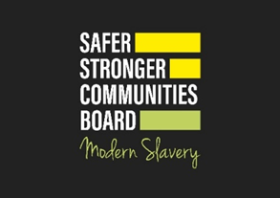
Members of the Public

MODERN SLAVERY AND HUMAN TRAFFICKING
HOW TO SPOT THE SIGNS & WHAT TO DO IF YOU HAVE CONCERNS

How to Spot the Signs Unseen Spot the Signs  Modern Slavery takes many different forms in the UK  A victim may have been trafficked either from another country or  within the UK in order to be exploited  This may be for labour exploitation, sexual exploitation, domestic servitude or criminal exploitation.  Human trafficking is the movement of people by means such as force, fraud, coercion, abduction or deception with the aim of exploiting them. | 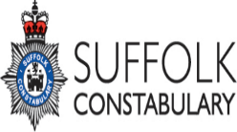  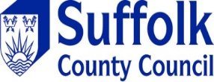  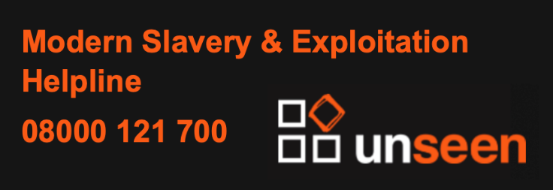

.”
Everyone has a responsibility to refer any concerns in relation to a potential victim of Modern Slavery and Human Trafficking

In emergency cases where there is immediate risk of harm to a potential victim or emergency treatment is needed Call 999

If you suspect a Modern Slavery crime is being committed but there is no immediate risk of harm, report
- to the Police on 101 or online Report | Suffolk Constabulary
- or the Modern Slavery & Exploitation Confidential Helpline 08000 121 700 Lines are open 24/7
- or Download The Unseen App

Telephone Referral
If you are concerned about a child or an adult and unable to use the online referral below, you can call Customer First on 0808 800 4005 (this is a freephone number)
If you don’t want to give us your name you don’t have to, the important thing is to let us know if you are worried about someone’s safety.
Online Referral Suffolk Safeguarding Partnership Report Concerns
Please use these forms for less urgent referrals only. If you feel the person is in immediate danger, please call Customer First on 0808 800 4005 rather than completing this form. Dial 999 in an emergency.
If you feel the need, as a member of the public, to raise your concern anonymously you can do so by clicking the link below:
Raise your concern anonymously about a child
Raise your concern anonymously about an adult
There are user guides and video guidance available below if you need help using the portals.
Access the Adult Portal User Guides and Video Guidance
Access the Children and Young People's Portal User Guides and Video Guidance
For more information:
Suffolk Constabulary
Suffolk Police Modern-Slavery

Suffolk County Council
Suffolk County Council Modern Slavery

All designated first responders should use the digital referral system to make National Referral Mechanism (NRM) referral

