Outcomes are the changes, benefits, learning or other effects that happen because of what the project or organisation offers/provides.

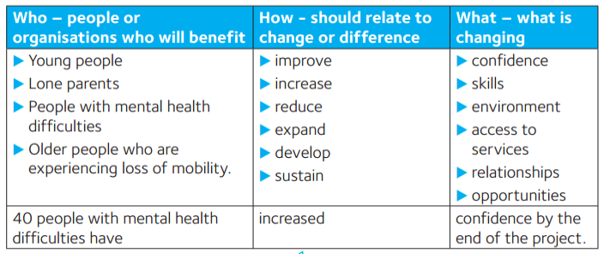
Outputs are activities, tasks, materials, or services that you propose to deliver. For example, providing mental health service for young people. Outputs are the things that you will deliver in the lifetime of the project.

The Number of Training Days provided
The Number of Beneficiaries supported
The Number of Counselling sessions provided
The Number of new Learners achieving Adult Literacy Level 2
The Number of trees planted
Two new Activity Groups established
The Number of participants that moved from Level 2 to Level 3 in Leadership
Reduction in measured Air Pollution at Location A

