Menstruation Resources Examples.

**Aim of the resource:**

This is a visual tool for enabling young people to understand the process of changing their sanitary pad by giving step-by-step instructions. It can be used alongside a tick chart so that they can keep track of when they have changed, or when they need to. It can be displayed in the bathroom at home, or they can have a copy to access at school to reduce the reliance on others to remind them.

**Aim of the resource:**

It is becoming increasingly popular for young people to use ‘Period Pants’ in favour of sanitary towels. This is a visual tool created to enable young people to understand the process of changing their period pants by giving step-by-step instructions. It can be displayed in the bathroom at home, or they can have a copy to access at school to reduce the reliance on others to remind them.

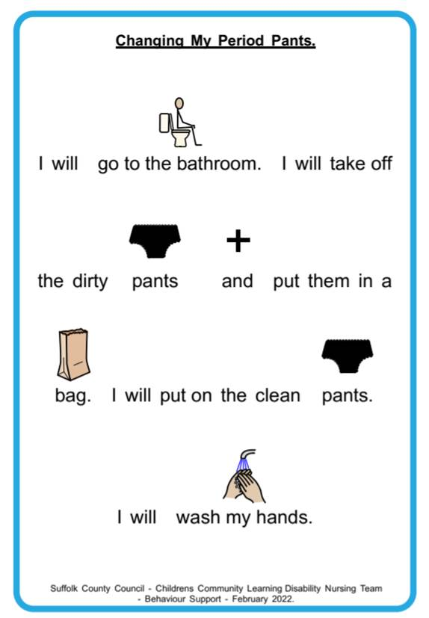

**Aim of the resource:**

It is becoming increasingly popular for young people to use ‘Period Pants’ in favour of sanitary towels. This is a visual tool created to enable young people with limited understanding to follow the process of changing their period pants by giving the basic step-by-step instructions. It can be displayed in the bathroom at home, or they can have a copy to access at school to reduce the reliance on others to remind them.