FMS Catalogue Instructions
Go to your shared area (this may be the S or G drive) and create a folder called “2022-23 Catalogue”
Run Anycomms (if you do not have access to anycomms please log a call with the IT Servicedesk telephone 01473 265555 stating that you need to be sent the Herts Stores HFS_SIMS_2022_2023.ex file by the SIMS Support team).
Go to the anycomms In-Misc folder and copy the file named HFS_SIMS_2022_2023.ex and paste it into your “2022-23 Catalogue” folder.
Right click on the HFS_SIMS_2022_2023.ex file and rename it to cat.exe
You will receive the following warning, click on Yes
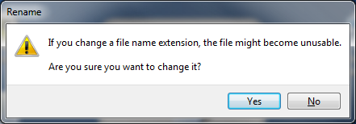
Double click on the cat.exe or cat shown below
Extract using WinZip or 7Zip:-
Make sure you browse to your “2022-23 Catalogue” folder, then click on unzip
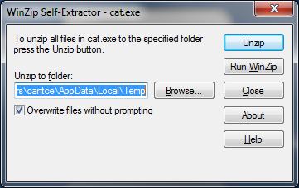

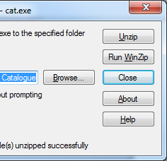
Once successfully unzipped click Close
If you don’t have WINZIP use 7Zip

Either method will create 7 new files:-

Or with file extensions:-
aexpand.bat
bexpand.bat
CATDBF.ZIP
Catmsg.txt
expand.bat
fms6.doc
install.bat
Open FMS
Go to Focus – Accounts Payable – Supplier
Browse to Procurement & Commissioning – Suffolk County Council (you may have set this up with a slightly different name).
Double click to open this

Go to tab 3 Catalogue
Click on Import Catalogue

Browse to where you created your “2022-23 Catalogue” folder. If you are unable to see your shared area in FMS you will have to move the 2022-23 catalogue folder to an area you can see.
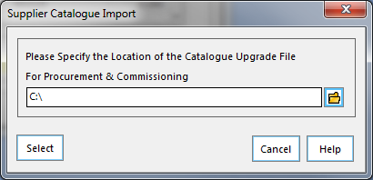

Double Click and select your CAT folder within the “2022-23 Catalogue” folder.
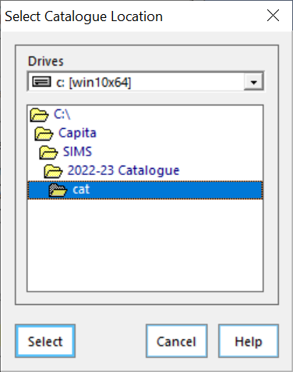
Select again and the import will take place.
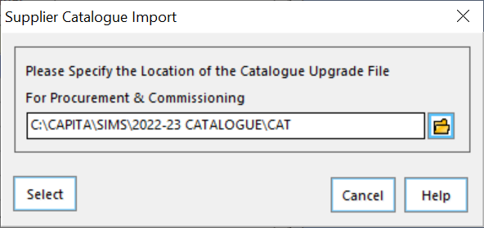

Once the progress bar closes the import will be complete.
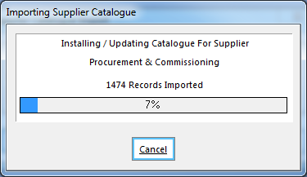

Last imported date = today
