Designated Teacher for Children in Care

A guide for Designated Teachers and PEP writers for Suffolk children in care

Introduction
This booklet is intended to support Designated Teachers and Designated Teachers in schools with Suffolk children in care on roll.
The booklet is an overview of the role, covering key areas regarding the education of a Suffolk child in care on your school roll.

It covers:
- What the Suffolk Virtual School is and what we do 3
- Your role as Designated Teacher (DT) 4
- Starting points for a new Designated Teacher/PEP writer 6
- Previously looked after children 7
- The Suffolk approach to PEP meetings and PEP documents 8
- The Suffolk model of Pupil Premium funding 10
- How to write an effective PEP for a Suffolk pupil 12
- Our work with you and your school 20
- Reporting to school governors or trust 21
- Our training offer 22
- Ofsted and children in care 23

Welcome to the Suffolk Virtual School
The Suffolk Virtual School is responsible for monitoring the educational experience and outcomes of each child in care.
We are part of Suffolk County Council and work closely with other services within the local authority, such as social care, school admissions and the teams that support young people with special educational needs and disabilities. This means that we can work with these services to make sure each young person has the most appropriate education and most positive experience that meet their needs.
We offer support, guidance, training and challenge to ensure that educational services are effective in maximising the progress the progress that our children make in school. We do this through:

- Tracking academic progress, attendance and exclusions of CIC
- Quality assuring all Personal Education Plans (PEPs)
- Providing support and challenge to schools to ensure that academic standards are raised for CIC
- Using our tracking data to highlight individuals who are not on target to achieve their predicted outcomes and challenging their settings to provide them with additional education support
- Ensuring Special Education Needs or Disability needs are identified and supported appropriately with an integrated plan
- Monitoring and challenging schools to make effective use of the Pupil Premium Grant for CIC
- Ensuring effective transition between schools or specialist providers
- Encouraging a culture that supports our young people to have high aspiration about their futures and removes barriers to further education
- Leading training for Designated Teachers, Social Workers, School Governors, Foster Carers and bespoke training for educational settings and staff in schools
- Providing advice to social workers and carers to ensure they contribute to the education outcomes of children on their case load or in their care placement
- Celebrating CIC achievements
- Supporting the delivery of the Children in Care Promise

We are responsible only for children who are in the care of Suffolk County Council. You may have children in care in your school from other local authorities. Their own Virtual School will be responsible for working with you to oversee their education.
Our Virtual School is comprised of the Virtual School Office and a Virtual School ‘field’ team.
Details of our team and their area of responsibility are on our webpages on the Suffolk County Council website. If you are unsure of who to contact with a query or issue, please call our office on 01473 260818 or email suffolkvirtualschool@suffolk.gov.uk
Our School Improvement team focuses on improving the outcomes of children in care by working with schools to develop best practice around provision and progress.
Our Inclusion and SEND Leads pick up cases that require more direct involvement; typically this will be a CiC who is experiencing significant disruption, either in school (such as exclusions) or in placement, or, for example, they might be new in care, having previously been electively home educated, and therefore require some intensive work with a range of professionals in order to secure an appropriate education provision.

Your role
Your role is to oversee and monitor the progress and wellbeing of each child in care on your roll. You are the person who coordinates their education provision and acts as their ambassador. This oversight occurs on a daily basis as you work with the young person, their carer or parent, their social worker alongside their teachers and support staff to ensure that the most appropriate support and interventions are in place to maximise their academic success and wellbeing.
One of the main roles of a Designated Teacher (DT) is to complete the termly Personal Education Plan (PEP) document. The PEP will be a record of all the academic support and interventions that your school has put in place (and adapted accordingly, where appropriate) to meet their needs. The primary aim of the PEP is to improve the academic outcomes of the young person and to provide them with opportunities to develop their academic, social and emotional skills. The PEP is an invaluable mechanism to ensure that the child or young person is on track to reach their potential and any barriers are identified and addressed.

Why is your role so important?
The outcomes of children in care are significantly lower than their peers. This may be for several reasons, including persistent school absence, lack of parental support, trauma suffered prior to going into care or frequently moving schools.

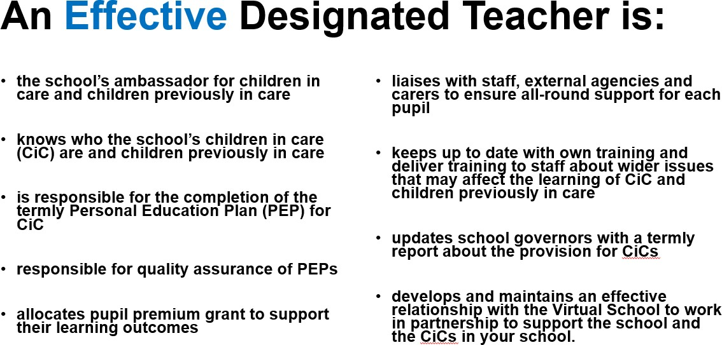

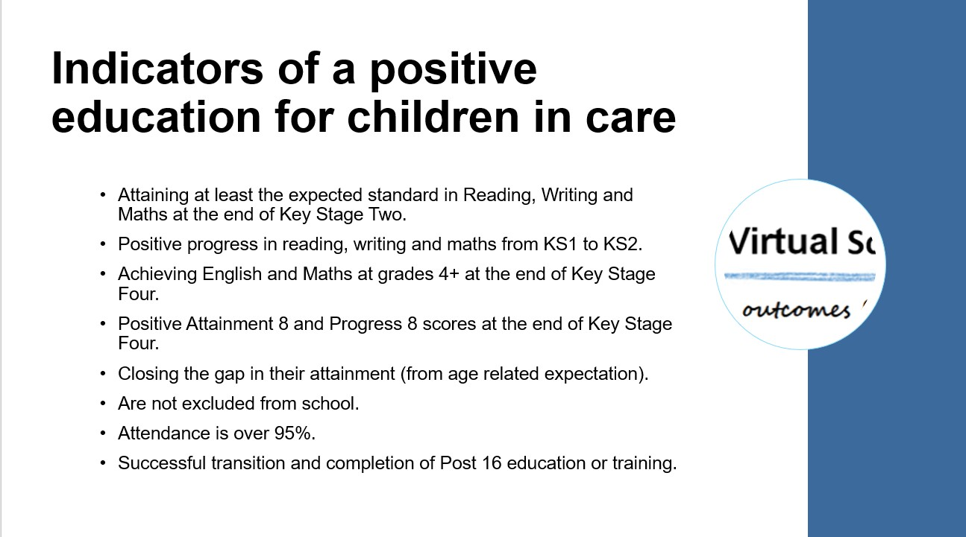

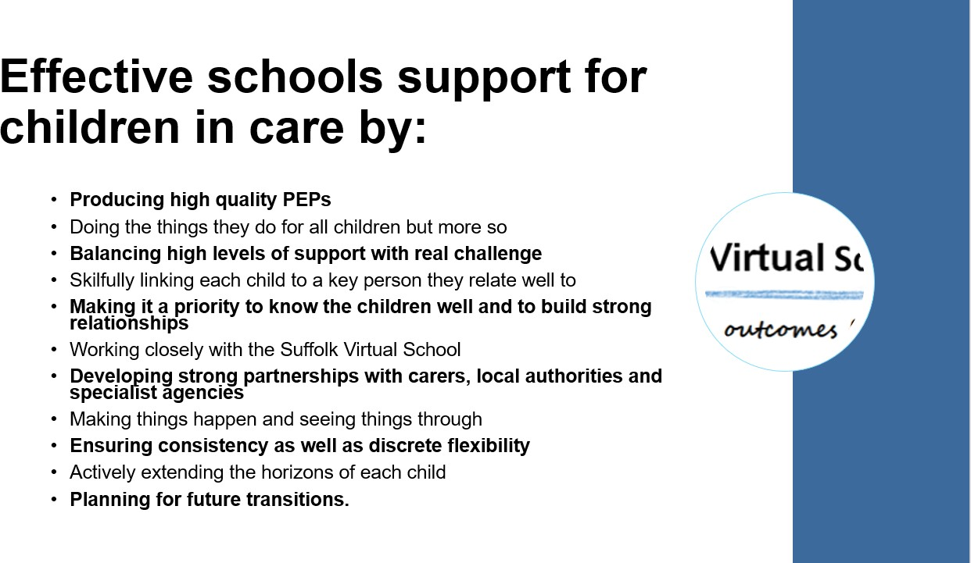

Starting Points for a new Designated Teacher

Become familiar with the statutory guidance which relates to children in care (and those previously looked after):

- The designated teacher for looked after and previously looked-after children Statutory guidance on their roles and responsibilities (DfE, February 2018)
- Promoting the education of looked after children and previously looked after children Statutory guidance for local authorities (DfE, February 2018)
These will give you a very clear idea of what your role and responsibilities are alongside your school’s governing body/trust and the Virtual School.
- Make sure you know who your school’s children in care are and what their legal status currently is (this could change over time). Their legal status will inform you of who is able to know information about the young person and who can make decisions relating to their education, If you are not sure of what their legal status is, the best thing to do is to contact their social worker.

- Make sure you know which local authority they are looked after by. The approach of each Virtual School is different so you will need to become familiar with key issues such as their PEP, funding model and their methods of working with schools.

- Introduce yourself to each young person, their carer and their social worker. They need to know who to contact at school when they have a question or want to let you know something that may affect the young person’s education.

- Know the contact details of your link(s) at each relevant Virtual School. The Suffolk Virtual School contact list can be found on our website https://www.suffolk.gov.uk/children-families-and-learning/children-in-care-and-care- leavers/the-virtual-school-for-children-looked-after/about-the-virtual-school/

- Make sure you have a log in for the online PEP system, Welfare Call. If you haven’t got one, please contact our office on 01473 260818.

Previously Looked after Children – your role and the role of the Virtual School
In 2018 the government extended the duties of all Virtual Schools and DTs to include previously looked after children (Post LAC).
The DfE guidance places a statutory responsibility on schools to monitor the outcomes and progress of children who have previously been in care but have gained permanency via adoption, special guardianship or child arrangement order.

There is recognition that the effect of being care and the reasons for it do not disappear once a child gains permanency.

The statutory guidance outlines the following direction for schools and the Virtual School:

- Schools should monitor the attainment of Post LAC as part of their tracking of vulnerable groups. Appropriate support and interventions should be put in place to meet each Post LAC’s needs, using Pupil Premium funding (via the school census) where necessary.
- Parents of Post LAC should be invited to be actively involved in the decision-making around how their child is supported
- The Virtual School Head is no longer acting as the part of their corporate parent: our role is limited to providing information and advice to parents and schools.
- DTs may seek the advice of the Virtual School about meeting the needs of individual children with the agreement of the child’s parents or guardians. General advice can be given with anonymity.
- Schools are not required to complete PEPs and there is no equivalent review cycle to the six monthly CiC Review.

For further information about your role in relation to previously looked after children, please refer to the DfE guidance The designated teacher for looked after and previously looked- after children: Statutory guidance on their roles and responsibilities (Feb 2018).

The Suffolk PEP Process

The Personal Education Plan (PEP) and the PEP meeting
The PEP meeting and the PEP document are both statutory aspects of a child in care’s care plan. They provide opportunities to plan, discuss and evaluate the educational experience of a pupil and to ensure that their needs are being met. The pupil’s own voice within these elements of their care plan is key to ensuring that their wishes and feelings about their education, aspirations and future plans are heard, recognised and acted upon.
In Suffolk the PEP meeting and the PEP document are not integral. The PEP document is solely the responsibility of the school, whilst the PEP meeting is the responsibility of the pupil’s social worker.
Schools must complete a PEP document every term. There must be clear evidence of planning and progression from term to term which has been informed by attainment data, pupil voice and the professionals working with the pupil to ensure positive outcomes and educational experience. PEP submission by the given deadline in one term will usually trigger a PPG payment in the following term. For example, a PEP submitted in the Autumn Term triggers the Spring Term PPG funding.
There is a minimum of two PEP meetings per year, and these must take place before each Child in Care review which are six monthly and chaired by the child’s Independent Reviewing Officer (IRO). An IRO’s duty is to ensure the care plans for children in care are legally compliant and in the child's best interest. All local authorities have a duty to appoint an IRO to every child in care.
As there are only two PEP meeting per year, this means that there will be one term in which there is no formal PEP meeting. In this term we advise schools to use their own gathering of pupil voice to ensure that provision matches their needs. This can be recorded in the PEP, which is covered in this booklet.

Best Practice PEP Meeting
The pupil’s social worker should inform you of the date and venue of the meeting. The young person may not wish for the school to attend or for it to be the venue, but you should still be made aware of the meeting so that you can contribute. A copy of the targets should be shared with the other participants and any further comments you wish to make about the pupil’s progress, attainment or support.
The meeting will be person-centred; the pupil’s wishes and feelings will be at the heart of the discussions. The school, their carer and their social worker will also contribute towards how things are going for the person and what can be done to make it even better. The PEP document – especially the targets – MUST NOT be set during this meeting to ensure that the meeting focuses on the young person instead of on paperwork.
After the meeting the pupil’s social worker should share the minutes with you so that you are able to follow up any actions required of the school. To ensure that you get a copy of the minutes you may find agreeing a timescale with the social worker is useful. The minutes of the PEP meeting should be uploaded in the pupil’s PEP Documents section and actions agreed in the meeting should be recorded in Tab 3 of the PEP, Person centred PEP meeting.
The following diagram illustrates how the meeting and the document work alongside each other:

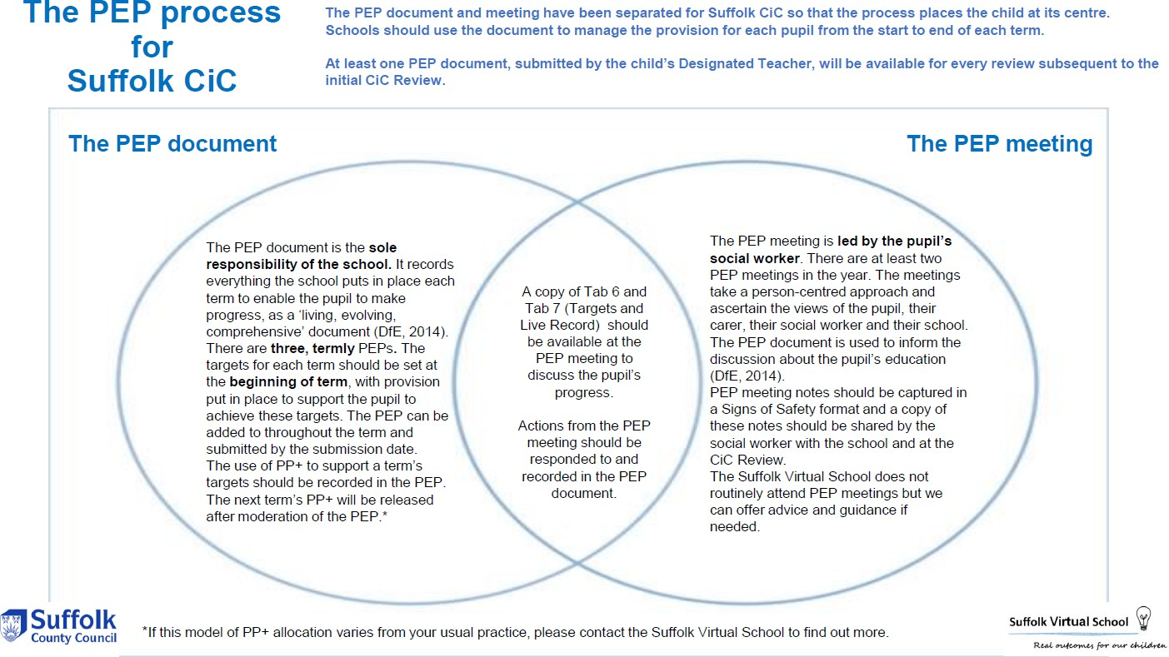

The diagram below illustrates how PEP meetings and CiC reviews fit in together:

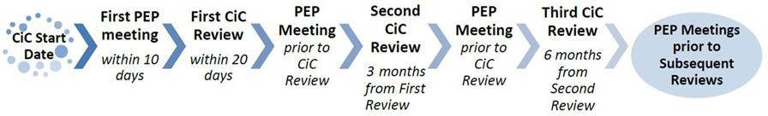

When a child is new into care or new to a school setting a meeting must be held within the first ten days of this date. The purpose of this meeting is to share key information about the child’s care placement and education provision and to begin the collaborative partnership working.
The subsequent PEP meetings should be person-centred, rather than a professionals meeting.
The termly PEP document will be shared and discussed as part of this process and it is important that you keep it up to date so that the plan to meet the pupil’s needs is always current.

Pupil Premium Grant (PPG) – the Suffolk Model
Children who are in local authority care (also known as “Looked After Children LAC, Children Looked After CLA and Children in Care CIC”) attract pupil premium funding known as the Pupil Premium Grant. Funding for these pupils doesn’t go to their school; it goes to the Virtual School Head (VSH) in the local authority that looks after the child.
VSHs are responsible for managing pupil premium funding for Children in Care. There is no automatic entitlement for the school to receive the funding and the VSH can pool funds or retain a portion of the full amount under the conditions of grant. The VSHs in most authorities retain a portion and use this in a variety of ways to support children to achieve good outcomes.
The following link gives further details of the pupil premium grant as it applies to children in care:
https://www.gov.uk/government/publications/pupil-premium-allocations-and-conditions-of- grant-2020-to-2021/pupil-premium-conditions-of-grant-2020-to-2021

Children in the care of other local authorities
School staff should note that for children in the care of different authorities the processes will be different from those described above. For instance, in one authority only £500 per term is passed to schools and in another all the funding is retained and schools asked to apply for it. There is also an example of an authority where the full amount is passed to schools at the beginning of the budget year.

Previously looked after children
Pupil Premium for adopted children, those on a special guardianship, child arrangements or residence orders Schools will also receive £2,300 for each pupil who has left local authority care (in other words, was previously in the care of ANY local authority) because they:
- were adopted
- moved onto a special guardianship order
- moved onto a child arrangements order (previously known as a residence order)
Please note that these funds come directly to the school and are NOT part of the process for children in care described above. To be eligible for this funding the child must be recorded in the January 2019 school census and alternative provision census and have been looked after by an English or Welsh local authority immediately before being adopted, or moving from local authority care onto a special guardianship order or child arrangements order (previously known as a residence order). These are collectively referred to as ‘post-LAC’ in the conditions of grant.
A school will receive £2,300 for each of these eligible children but may only be aware of their status if they were on roll when they were previously looked after or if parents and carers have declared that they are adopted, or on a special guardianship, child arrangements or residence order. Suffolk County Council cannot help identify these children as it may be that the child was in the care of a different local authority. Therefore, schools will want to be sensitive about how they raise the awareness of parents and carers in an effort to discover whether there are any children on the school roll who would be eligible if a parent/carer

declared their status. It is also for schools to verify to their satisfaction that the parent/carer declaration is accurate perhaps by being shown the relevant legal order. The conditions of grant say that the Pupil Premium Grant provides funding for two government policies:
- raising the attainment of disadvantaged pupils and closing the gap with their peers

How to use Pupil Premium Funding
Each local authority will have its own approach to providing schools with Pupil Premium funding and have their own guidance on what schools may use the funding for. You should contact the Virtual School for a child who is not looked after by Suffolk to find out what their funding model is.
We operate a match-on-match funding model: schools record the amount of PPG spent a pupil in the termly PEP and this is the amount of PPG they will receive the next term to spend on support and interventions. This amount is capped at £600 per term and is dependent upon PEP compliance. If a school requires more than the amount they received in a term to put in place support and interventions they can apply for additional funding. If you need to do this, please contact the relevant Virtual School Lead or our office to discuss.
In Suffolk, we encourage schools to consider each pupil’s needs individually to decide how the funding should be used each term, but as a rule, we do not encourage it being used to fund the following:
  - The purchase of laptops or other devices
  - Fees or equipment for leisure activities
  - School uniform
  - Trips that are not linked to the curriculum, such as optional leisure trips

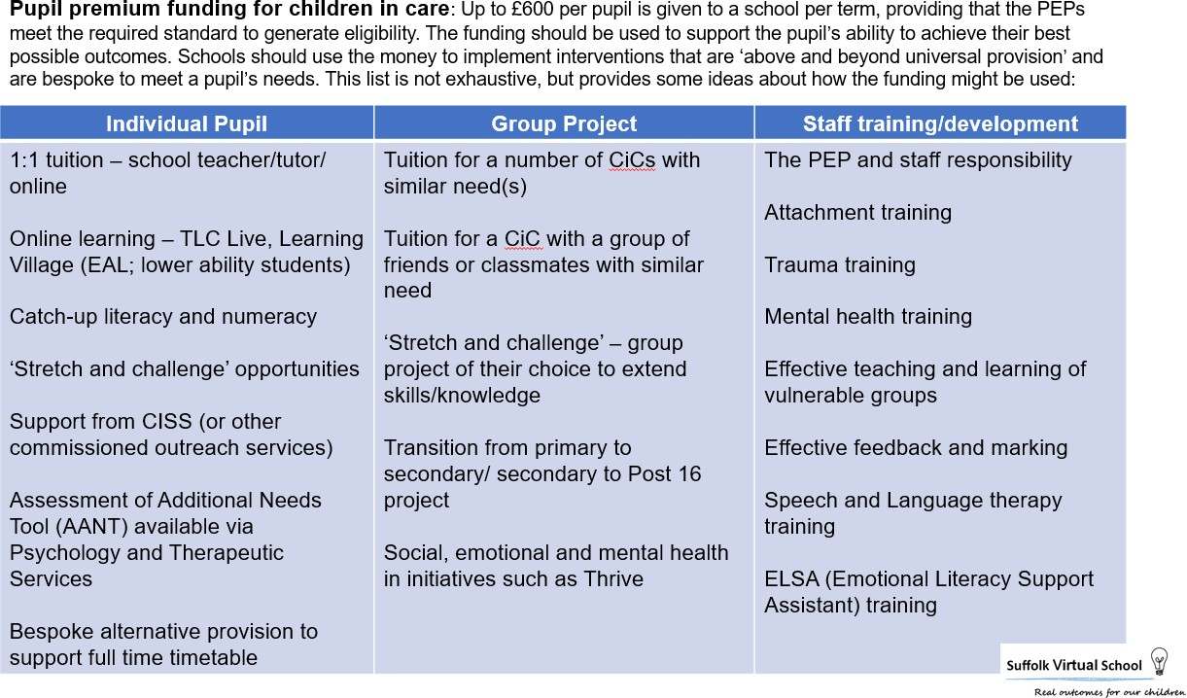

Please contact the relevant Lead at the Virtual School if you have any questions about the allocation of PPG or its use to support a pupil

Writing a highly effective Personal Education Plan
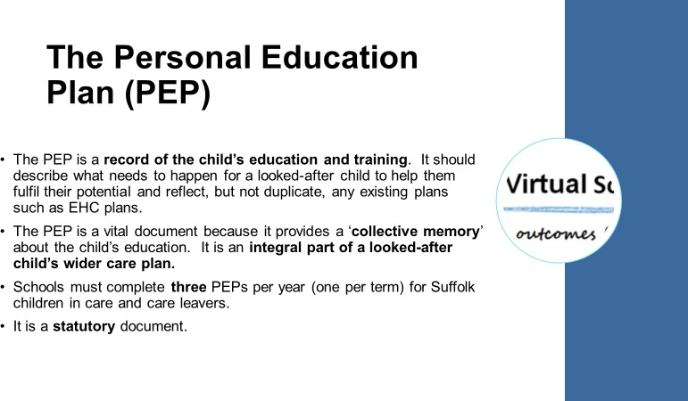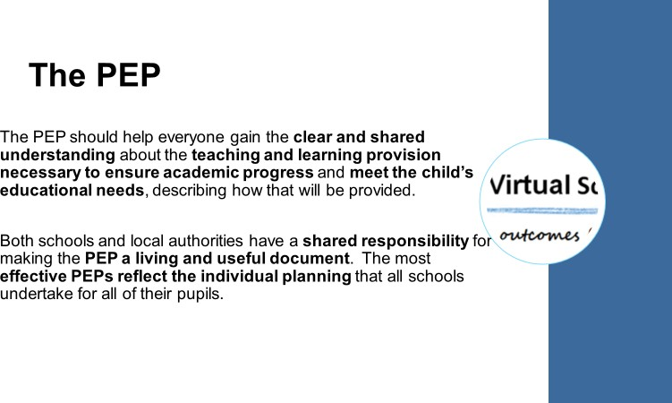

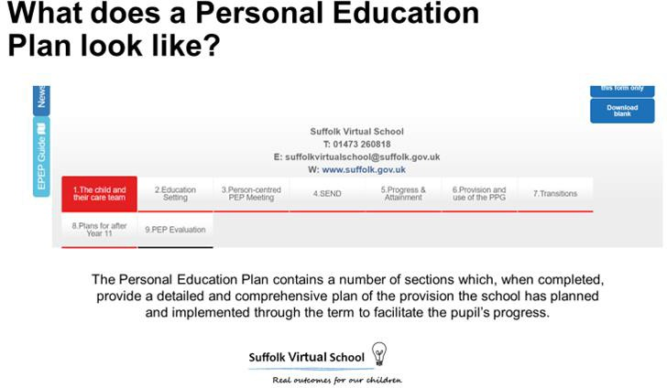

Know your pupil
The aim of a pupil’s education plan is to formulate a term by term strategy to maximise their outcomes, academically and socially/emotionally.
There will be a range of information that will need to be considered when formulating the plan:
  - Pupil’s wishes and feelings
  - Attainment data – current performance and outcome estimates
  - The wishes and feelings of key stakeholders in the young person’s care (carer, social worker, school, possibly parents)
  - Their social and emotional well-being, which is assessed via a Strengths and Difficulties Questionnaire (SDQ). The questionnaire identifies the young person’s mental well-being through a series of questions. Their social worker is normally responsible for administering the questionnaire and it is normally completed by their carer, although they and school can also complete the questionnaire. Best practice is that an SDQ is completed on an annual basis. The score should be used to implement appropriate support and SEMH interventions, alongside academic provision. Other assessments such as Boxall or Thrive may instead be used.

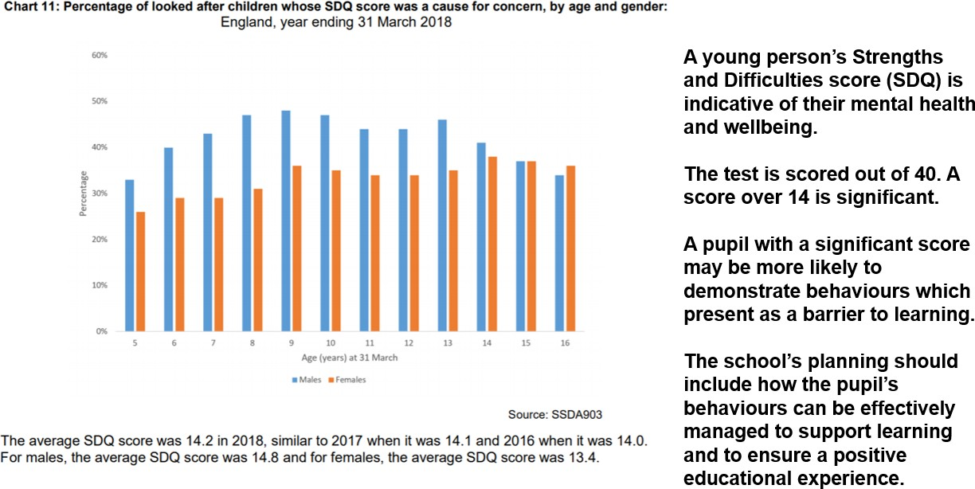

Working in partnership with your colleagues
Although you will oversee the progress and provision for each child in care, your colleagues may have more day to day contact with them or have a specific key role in their provision plan. It is important that you liaise with your colleagues to ensure that the pupil’s provision (and thus how it’s recorded in the PEP document) is effective. For example, we would strongly encourage you to ask the pupil’s class teacher or teachers to set the termly targets.

Their form tutor, Head of Year or Director of Learning may have frequent contact regarding SEMH support for the pupil. If the pupil has an EHCP or SEN support, it is best practice to involve your school’s SENDCO in the pupil’s plan each term. Equally, for pupils in Year 8 – 13, it is best practice to involve your school’s Careers Lead too.
We encourage DTs to set up access to the PEP document for other staff so they can add details to the PEP as and when they can during the term. Details of how you can do this are below in How to complete each section of the PEP.

The Welfare Call ePEP
The Suffolk Virtual School uses the online ePEP from Welfare Call. Welfare Call are the organisation that collects attendance data for each Suffolk child in care daily.
You should have received a log in for the ePEP system when your details as your school’s DT were shared with us. If you haven’t received one or have problems logging on, please contact our office on 01473 260818.

Dual registered pupils
If a pupil is dual registered, we would expect the setting where they are attending to complete the PEP document. We would, however, ask the two settings to share and contribute information about provision and progress as much as possible.

Best practice approach to planning provision each term
The PEP is designed to be a record of the planning, implementation and reviewing of each pupil’s plan. Details of these plans should be recorded as they are put in place, reviewed (and amended where appropriate) so that the PEP is a picture of the whole term rather than a snapshot of one moment in time.
The diagram on the next page explains how best to approach the recording in the PEP.

Meeting the PEP deadline
The DfE guidance for PEPs states that they are a ‘living, evolving document’. We set our PEP submission date for near to the end of term to reflect this. We would ask that PEPs are submitted just before or on the submission date. As the PEP meeting and PEP document are separate for Suffolk pupils the document does not need to be submitted as soon as the meeting has taken place (unless it takes place just prior to the submission date) and targets should be set at the start of each term, not in the PEP meeting.
It is important that the PEP submission date is met by schools; if the PEP is submitted late this may affect the funding that a school receives for a pupil the following term.

How to complete each section of the PEP

Tab 1: The Child and their Care Team
- This section records the basic information about the pupil and the adults that look after them
- Please make sure the information recorded is accurate
- Please do not attempt to overwrite any of the fields with a grey background.
- If any of the details contained on this tab need to be updated, please flag to the Suffolk Virtual School on 01473 260818 or securely by email: suffolkvirtualschool@suffolk.gov.uk
- If unsure of any details, please contact the pupil’s social worker
- If the pupil is new into care, this section can be completed as part of the initial planning meeting which should take place within 10 days of them entering care

- A Strengths and Difficulty Questionnaire (SDQ) score is an indicator of the pupil’s mental health. They are usually completed annually and via social care. The score is out of 40. 0-14 is regarded not to be of concern; above 14 is significant. If an SDQ has not been completed but another similar assessment has been, such as Boxall or Thrive then this should be attached to the PEP in the Documents section. If the pupil has an SDQ of 14+, please set an SEMH target with a measurable outcome.

Tab 2: Education Setting
- This information can be updated from the pupil’s record.
- Q10: for pupils who are dual registered, please provide the contact details for the Designated Teacher of the other provider; both settings will then have access to the PEP.
- Qs11-13; if the pupil is accessing alternative provision, please provide the information requested. It is also possible to provide temporary log ins to APs; please contact the Virtual School to request this if appropriate.
- Q21 (Exclusions): please log fixed term exclusions and use of the school’s internal exclusions
- Q23 (Agencies involved): please include details of agencies who are currently involved and those who have been involved with the pupil historically. The YES/NO option in the involved column will reflect the live or not status of each agency.
- Q24 (Other people to support CiC): include here all the people in school who work with the pupil and are therefore likely to be mentioned elsewhere in the PEP. For example, their form tutor, career advisor, Learning Support Assistant.
- Quality Assurance: the PEP needs to be signed off by the Designated Teacher once fully complete and prior to submission. Their name should be recorded here in this box.

Tab 3: Person-centred PEP Meeting
You will need to record the date of the most recent PEP meeting. If there hasn’t been one, please indicate this in the relevant box.
Indicate if the meeting captured the views of stakeholders. A Yes/No dropdown option is available in each box.
Use the Actions from last PEP to record how the school has responded to actions arising from the last meeting. The Actions section at the bottom of the tab should be completed with details of each action that needs to be taken as a result of the most recent meeting, including by whom and by when each action should be completed.
If there is no PEP meeting in a term, please use our own pupil voice work to shape the actions to recorded and implemented in the bottom section.
The pupil’s social worker should share the minutes of the meeting with you and these should be attached to the PEP in the Documents section.

Tab 4: SEND
- Questions 1 and 2 must be completed for all pupils.
- The remaining questions only need to be completed if the pupil has an EHCP or is on SEND Support.
- Please inform the Virtual School if you are considering a request to assess for an EHCP or an application for High Needs Funding.
- For pupils with an EHCP please upload their Moving into Adulthood plan into the Document section.

Tab 5: Progress and Attainment
- Please complete information about all subjects specified in this section.
- Previous attainment data such as Key Stage 1 or Key Stage 2 scores should be recorded in the relevant section.
- If the pupil is being assessed using the pre-key stage criteria, provide information about their progress using the pre key stage descriptors. This can be recorded in the Additional Notes box for the relevant term.
- Test and mock exam scores can be recorded in the Additional Notes section for the relevant term.
- Please attach the most recent progress report and work samples that relate to scores recorded in the Documents section.

Tab 6: Targets
- Please review previous targets with the CiC at the beginning of the term.
- After completing the review of previous targets, please set new targets in collaboration with teachers, key workers and the CiC. You may wish to use the document ‘PEP planning sheet’ to retrieve multiple academic targets across multiple subjects. This can be downloaded from our webpages.
- You may wish to also add a ‘delegate’ to complete the targets section. This can be achieved by granting access for as long as you deem necessary to a class teacher or key worker. To add members of staff as delegate PEP authors please Hover over EPEP > DT Delegation > Request new Delegated user > following instructions on this page
- If you require more than three targets - on completion of a third target, the section will automatically generate a new empty target box.

For more guidance, please see the exemplars for EYFS, Key Stage 1, Key Stage 2, Key Stage 3, Key Stage 4 and CiC attending alternative provision in the Documents section of the PEP.

Exemplar SMART targets
Pupil A to sustain a 9+ years or increase her reading age by a further 6 months in the next reading assessment (Accelerated Reader Star test) by the end of April 2021. She is to read books of an average 2.6 book level; to sustain an 85% correct book quiz average. She will read regularly at home and at home, acting on teaching advice.

Pupil C will securely meet the criteria for a GCSE grade 5 in Maths by showing an ability to generate strategies to solve mathematical and non-mathematical problems by translating them into mathematical processes. C will be able to interpret results in the context of the given problem and be able to evaluate methods and results.

There is a planning proforma that you could ask teaching staff to complete when setting targets each term for a pupil. Teachers will know the pupil, their current level of performance and their subject’s assessment criteria. This knowledge leads to more effective and challenging targets.

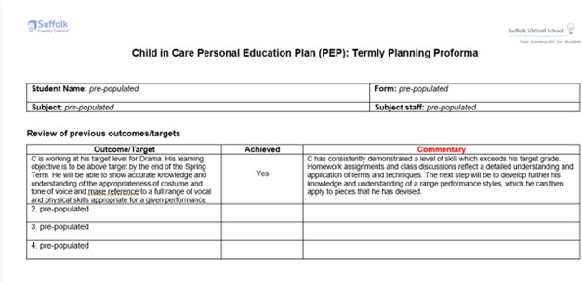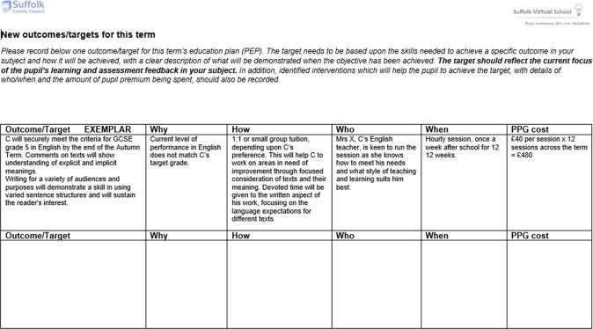

Tab 7: Live Records
  - Both live records (academic and SEMH) are designed to be continually updated throughout the term by multiple contributors. This is so progress can be measured in more than just academic measures and so that any adapting school practice and/or provision can be recorded.
  - Please date each entry, for example: 14/09/2019 – We have seen progress in…

For more guidance please see the exemplars for EYFS, Key Stage 1, Key Stage 2, Key Stage 3, Key Stage 4 and CiC attending alternative provision.

Tab 8: Transitions
  - Only complete this section if applicable.
  - You do not need to complete this section if the pupil is in Year 11
  - If the pupil is moving schools mid-year, please complete as much of the PEP document as you can, including details of the transition arrangements in place to support the move. If you are the receiving school, you will then be able to update the PEP prior to submitting it for the end of term deadline.

Tab 9: Plans for after Year 11
The statutory guidance for schools ‘Careers guidance and access for education and training providers’ (2018) states that children in care in Years 8 – 11 should receive ‘strong support’ with regards to careers guidance. Guidance about what this support could look like in relation to the PEP process can be found on our webpages.
  - Please complete for all pupils in Year 8 and above
  - All boxes need to be completed for each pupil.
  - Details about support for Years 8, 9 and 10 may reference general events such as career days as well as individual career interviews, rather than specific details about applications that will be recorded for Year 11. These can be recorded in box 7
  - These events, such as taster days, can also be recorded for Year 11 in the Additional Information box
  - Schools will need to ask permission from the pupil (if over 16; if under 16 permission must be sought from adult with parental responsibility) to attach a copy of their CIAG interview to the PEP
  - The school’s Career Lead could be given a log-in for Welfare Call to complete this section.

Documents
Documents attached to each PEP provides evidence of the provision in place and the impact that the school’s plan has had on the pupil’s attainment and well-being:
    - Teachers could provide evidence of progress via samples of work – ideally, one at the start of term and one towards the end of the term to show progress against the target.
    - It could be an essay, a test, a photo of a project or other document that can show a demonstration of development of a skills/knowledge included in the target.
    - A pupil’s EHCP or one-page profile are effective attachments
    - PEP meeting minutes

How to attach documents
In the top right-hand corner of the PEP document is a link to the Documents section. In the Documents section on the right-hand side of the screen are details of how you can attach a piece of evidence: name it, select the type of document it is and then attached using the Choose file button. Documents can be uploaded at any time in the term and remain in the Documents section.

Our work with you and your school

Visits and meetings
We visit every school with Suffolk child in care on roll at least on an annual basis. This visit allows you and the relevant Virtual School Lead to discuss the provision and progress of each pupil. This dialogue provides an opportunity to consolidate how best to meet the needs of each pupil and to share best practice. Feedback about the school’s PEP may also be given to also share best practice. We will write a report after the visit and send you a copy, which we would encourage you to share with your line manager and senior leadership team. We will contact you in advance to arrange the meeting but you are also to request a visit if you would like us to support you with something in particular or wish to undertake a review of your practice.

PEP moderation
Each term’s PEP will be moderated by the relevant Virtual School Lead. The purpose of the moderation is to establish the effectiveness of the provision and subsequent progress of each pupil. A rating system is used – gold (highly effective), green (effective), amber (requires improvement) and red (inadequate and funding will not be issued). You will receive notification of each PEP’s rating once it has been moderated. There is also feedback provided in the comments box in the PEP evaluation tab to support your completion in the following term. We may ask to meet with you to go through this feedback too.

Contact about individual pupils
We may make contact about a specific pupil to discuss their provision. For example, if a pupil has received a fixed term exclusion the relevant Virtual School Lead will make contact to discuss the strategies that the school will be using to avoid this from occurring again.
We do not attend CiC reviews or PEP meetings, unless there are exceptional circumstances. We are always available to provide advice, support and guidance, however, if you wish to discuss the situation with a particular pupil.

Reporting to your governing body/trust
As DT, you will be responsible for monitoring and reporting on the progress and attainment of your school’s children in care. You are required to do this at least on an annual basis but doing so on a termly basis is regarded to be best practice. Your report should consist of a narrative which reflects the following questions which are adapted from statements about the role of a governing body in the statutory guidance (2018):
To protect a child’s need for confidentiality it is important to ensure that the reports do not mention individual children by name. The report should enable the governing body to make judgements about the school’s provision for children in care:

  - The number of children in care at the school and the number of local authorities which are involved, as well as the number of previously looked after children that the school as formal notification of
  - any issues that have arisen as a result of the number of children in care and children previously in care or local authorities involved

  - whether looked-after and previously looked-after children have made the expected or better levels of progress over the past twelve months in line with their peers (i.e. educational, social and emotional progress) *

  - the pattern of attendance and exclusions for looked-after and previously looked-after children is different to that of other children at the school

  - for looked-after children, whether the school’s policies are sensitive to their needs, e.g in accessing out of school hours learning, respecting the children’s wishes and feelings about their care status or generally meeting their needs as identified in their personal education plans (PEPs)*

  - how the school is responding to any additional safeguarding challenges for children in care and children previously in care of which the school’s designated safeguarding lead should be aware

  - whether any looked-after and previously looked-after children have special educational needs (SEN) and whether those needs are being identified and met at the appropriate level

  - whether any looked-after and previously looked-after children have mental health needs and whether those needs are being identified and met

  - whether any are identified as ‘gifted and talented’ and how those needs are being met

  - how the school’s behaviour management policy has been adapted to be sufficiently flexible to respond to children in care and children previously in care’s challenging behaviour in the most effective way for those children*

  - any process or planning issues arising from the implementation of the action plan to raise achievement in the personal education plans (PEPs)

  - what impact Pupil Premium Funding (specifically pupil Premium Plus) has had in improving the educational outcomes of each child in care or child previously in care

  - how the teaching and learning needs of children in care are reflected in school development plans and are being met in relation to interventions and resources*

  - training undertaken by the Designated Teacher to impart knowledge and understanding about the education and wellbeing of children in care and previously looked after children to colleagues

  - work with the Virtual School leadership team and external agencies both in Suffolk and their equivalence in other Local Authorities

  - the impact of any of the school’s policies, for example on charging for educational visits, extended school activities and transport on children in care.

Source
The designated teacher for looked after children and previously looked after children: Statutory guidance on their roles and responsibilities, DfE, February 2018 (with effect from September 2018)

*Italicised bullet points may not be required to be included in every report, if governors receive more than an annual report.

Our training offer
To support our DTs, new and experienced, we provide a range of training. We complete face to face visits with each school and DT at least on an annual basis. The visits provide us and DTs an opportunity to discuss and evaluate the progress and provision of each Suffolk child in care. These discussions also facilitate professional development by sharing good practice and providing updates in legislation and guidance. We will contact you to arrange a visit, but you can also request one at any time if you would like some support or want to reflect on your practice.

In addition, network meetings are held on a termly basis and these are delivered in each area of the county – south, north and west – to enable as many DTs to attend. The network sessions are varied in format but always aim to share good practice around the education and support for children in care and to enable DTs to contribute to the sessions with their own experiences. They’re a really good opportunity to build up networks with other DTs who are local to you or to complete some partnership working with another DT in a different setting or area.
We also offer free of charge online training packages to DTs. Online courses about attachment and trauma are available and access to these can be requested from the Virtual School office or via your Virtual School contact.

Ofsted
From listening to school leaders who have recently experienced the new Ofsted framework, you may be asked about children in care in your school.
To prepare for this possibility, it would be useful to prepare at least one case study about the impact of the tracking, support and interventions that have been put in place to improve academic outcomes and the well-being of a child in care.
In addition, you may find it useful to prepare responses to the following questions that Ofsted may ask as part of their wider discussion with you:
Who is the head of the Suffolk Virtual School?
How many children in care do you have in your school?
Do you have an up-to-date Personal Education Plan for each child?
How is the pupil premium used to support each child in care?
How do children in care compare to academically and socially to their peers and other groups?
How does the school support national and local targets for children in care?
How does the school’s policies actively support children in care?
Are Governors aware of the progress of children in care and how is this achieved?

And finally: Top Ten Tips for New DTs

- Keep in regular contact with the Virtual School Team and visit our webpages for updates; notify us of any concerns as soon as possible. 01473 260818 suffolkvirtualschool@suffolk.gov.uk For contact details of other Virtual Schools please see the website of the pupil’s local authority
- Welfare Call ePEP – know your login details and keep your account active.
- The PEP document – you are responsible for the content of the online PEP document and this needs to be completed and submitted on Welfare Call on a termly basis.
- The PEP meeting – pupils need to have at least two of these a year. Although the social worker is responsible for co-ordinating and facilitating the PEP meeting, if they are unavailable, this should not prevent the meeting taking place.
- The CiC Review – this is the review of the child’s care plan. They happen every six months and are chaired by the Independent Reviewing Officer (IRO). The PEP needs to be in date for this review.
- Pupil Premium Grant – the Virtual School releases this to schools for eligible pupils on a termly basis. In exceptional circumstances, schools can also apply for additional Pupil Premium Grant payments. Requests will be considered on a case-by-case basis by the Virtual School team.
- Understand the roles and responsibilities of all those involved in the child’s plans, i.e., your own, the social workers, the carers, the IRO and the Virtual School.
- Read the statutory guidance and share this with your leadership team and your governors.
- Refer to CISS, education psychology and therapeutic services and Family Services Co-ordinators, as you would for children who are not in care.
- Develop the strategic aspects of your role. Provide CPD around attachment and trauma and cognition and learning for example. Review policies and procedures that impact on CiC.

