Sue Roper
Assistant Director Strategic Development
Suffolk County Council
15-17 Russell Road
Ipswich IP1 2DE

25 May 2018

Dear Sue

Transforming Cities Fund

Thank you for presenting to the Ipswich Vision Movement Working Group the proposals to address a number of key transport challenges, faced by Ipswich Borough and Suffolk Coastal District Councils, which Suffolk County Council intends to submit to the Transforming Cities Fund for the Friday 8 June 2018 deadline.

The Suffolk Chamber of Commerce Transport and Infrastructure Manifesto, in support of economic and business growth, includes a priority to “Reduce local congestion…to support town centre development and extend employment reach.”

The manifesto of Suffolk Chamber of Commerce in Greater Ipswich seeks “improvements to local traffic congestion for example on Futura Park, Ransomes Europark, the Star Lane gyratory and the bottlenecks into and out of town such as the A1156, A1189, A1214 and A1071” and supports “Park and Ride, cycling and public transport initiatives to reduce congestion.”

Suffolk Chamber of Commerce in Greater Ipswich identified in the same manifesto the intention to “Lead the Ipswich Vision ‘Movement’ Working Group to ease movement especially between the Waterfront and the Town Centre.”

We believe that the Suffolk County bid to the Transforming Cities Fund will support these objectives, the objectives of the Ipswich Vision Movement Working Group and the wider aims of Ipswich Vision regarding the economic and business growth of Greater Ipswich.

We therefore confirm our strong support for the outline proposals and look forward to working with you from the business perspective as they are further refined and delivered.

Yours sincerely
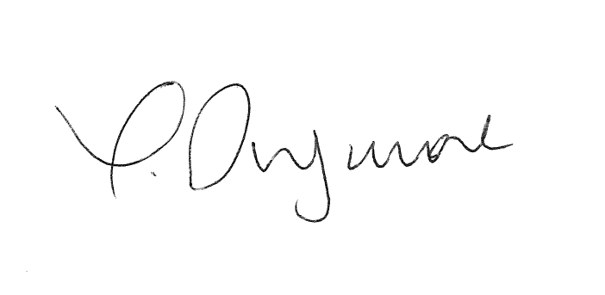
John Dugmore
Chief Executive, Suffolk Chamber of Commerce
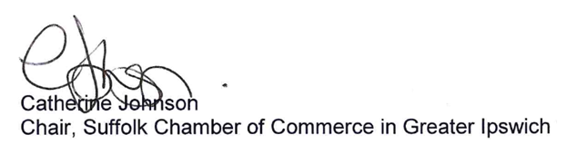

Cc

Joseph Hough, Suffolk County Council
Terry Hunt, Ipswich Vision
Graeme Mateer, Suffolk County Council

