**My calming down techniques when I am angry**

**First, focus on breathing then**

**Count to 10**

**1, 2, 3, 4, 5, 6, 7, 8, 9, 10**

**Think happy thoughts**

**Take deep breaths**

**Count backwards from 10**

**10, 9, 8, 7, 6, 5, 4, 3, 2, 1**

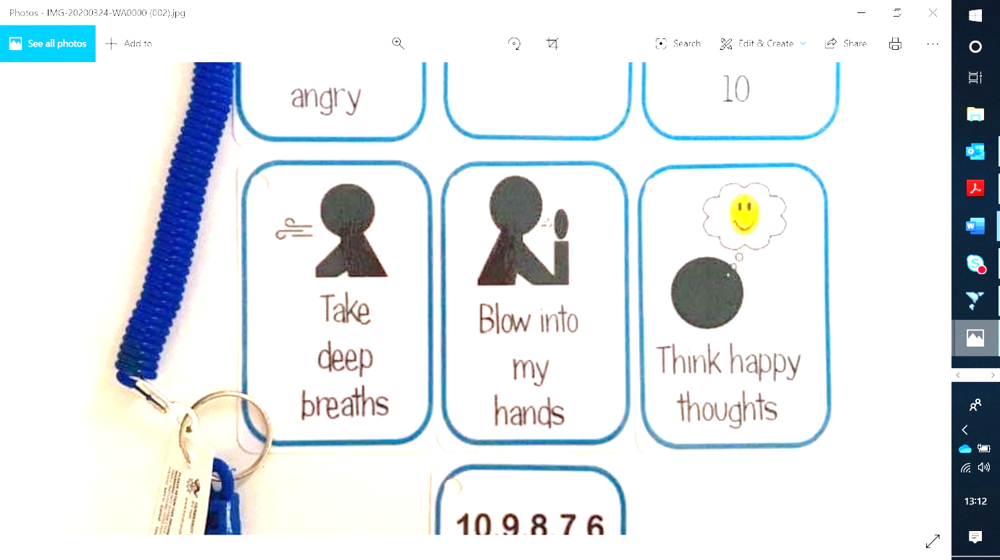

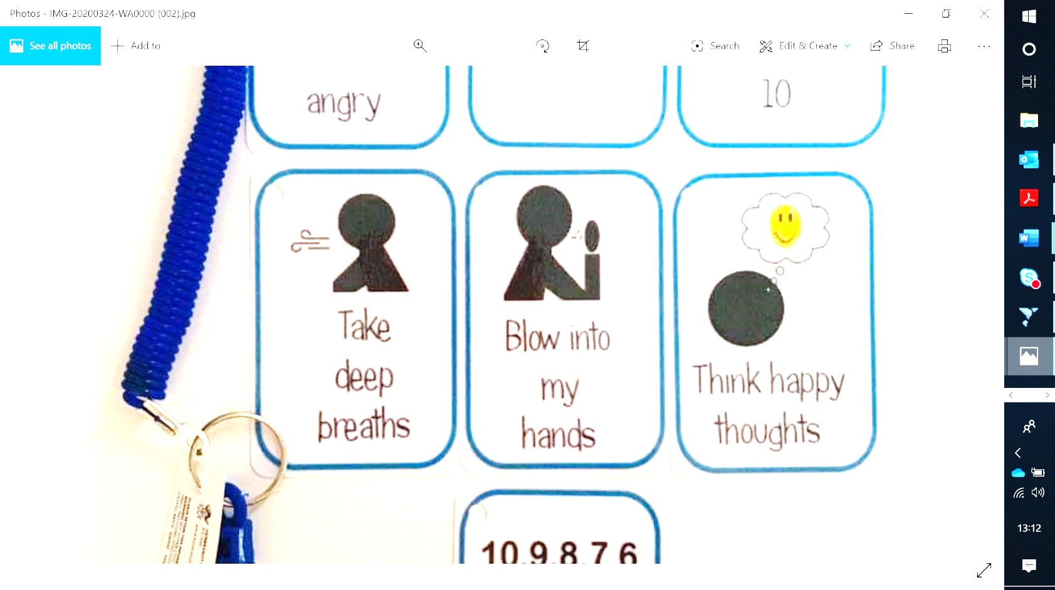

**If I feel**

**SAD**

**I can try:**

**-Taking some deep breaths**

**-Sing a song in my head**

**-Squeeze my squeeze ball**

**-Put my sad thoughts in my pocket**

**-Tell an adult I feel sad**

**-Ask for timeout**

**I feel HAPPY**

**Everything is ok**





**If I feel**

**ANGRY**

**I can try:**

**-Taking some deep breaths**

**-Sing a song in my head**

**-Squeeze my squeeze ball**

**-Put my angry thoughts in my pocket**

**-Tell an adult I feel angry**

**-Ask for timeout**

**If I feel**

**WORRIED**

**I can try:**

**-Taking some deep breaths**

**-Sing a song in my head**

**-Squeeze my squeeze ball**

**-Tell an adult I feel worried**

