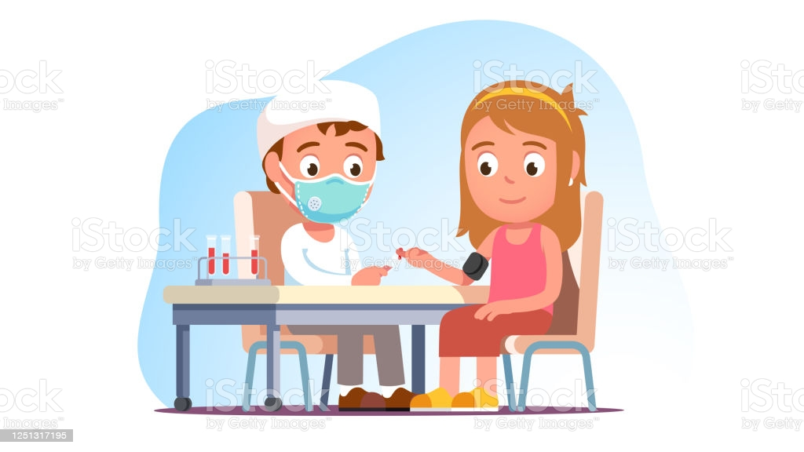

**NAMES’s Story**

**Going to the hospital**

**Getting bloods taken**

**I’m getting a blood test.**



**Travel in the car**

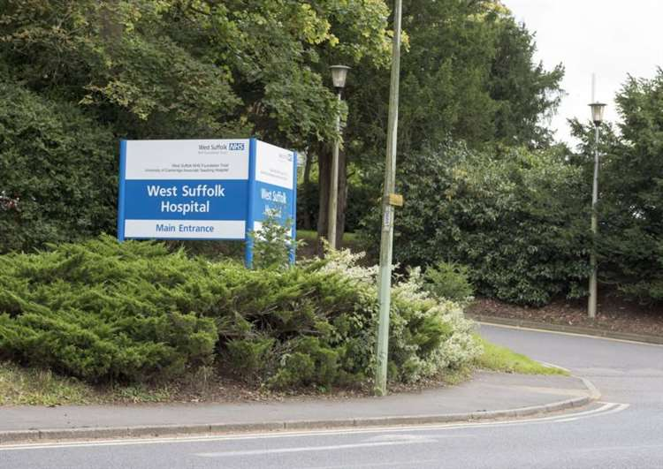

**See the hospital sign**

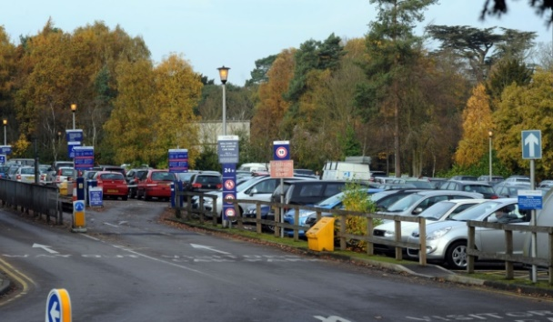

**Park the car**



**Walk in the entrance**

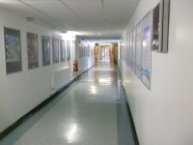

**Walk through the corridors**

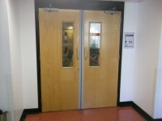

**Find the pathology doors**

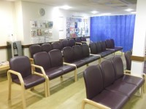

**Sit in the waiting room.**

**Good waiting.**

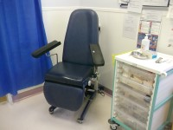

**Go into the clinic room**

**The nurse will put a band round your arm.**

**It will be tight, but it won’t hurt.**

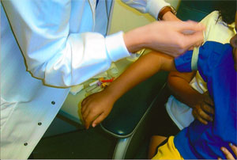

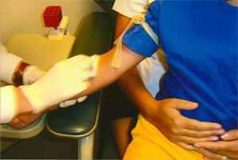

**The nurse will wipe your arm.**

**It might be cold, but it won’t hurt.**

**It is very important to sit very still now.**

**The nurse will take your blood.**

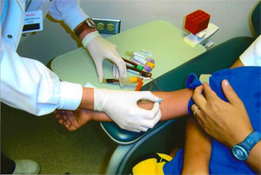

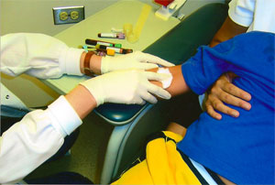

**The nurse will hold a cotton wool bud on your arm for a little while.**

Then…

**YOU’VE FINISHED!**

**WELL DONE!**



