ANNEX 03 - A1156 Norwich Road Delivery Management

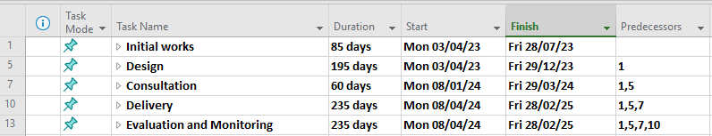

Initial Works
On the successful outcome of the bid, we expect initial works to commence shortly, at the start of the next financial year
This would include the creation of the stakeholder group and initial engagement with stakeholder members including third-party members. Within the same period we would confirm the designer for the scheme.

Design
Designer and project manager to discuss / review designs for the schemes on regular intervals with input from stakeholder members including third party members as required. Extra consideration has been given to the timeframe for design due to possible future projects being discussed or planned along the same route or section.

Consultation
It is expected that during the design period, the cabinet member for Highways and Infrastructure would be consulted on the designs as they are progressed to final design.
During the same period, we would carry out a six-week public consultation to get feedback on the intended scheme and review comments as required. We have allowed a three-month period for consultation to allow review and the possibility of additional engagement, if required.

Delivery
It is expected that individual delivery dates would be established towards the end of the design and consultation period given the need to allow traffic management, materials and staff etc to be planned.
We anticipate there to be an allowance of additional time for measures that require third party input.

Evaluation and Monitoring
We expect evaluation and monitoring to take place as soon as the scheme begins to be delivered.
Data analysis would be reviewed as part of scheme evaluation towards the end of delivery.

